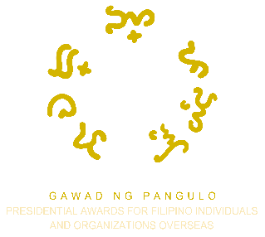
2024 Presidential Awards for Filipino Individuals and Organizations Overseas
ENDORSEMENT FORM

This form shall be accomplished only by the Embassy of the Philippines or Philippine Consulate General, which has consular jurisdiction over the place of residence, work, or operation of the individual or organization nominee.

ENDORSING PHILIPPINE FOREIGN SERVICE POST
Embassy of the Philippines/Philippine Consulate General | Name of Nominating Party
Name of Nominee | Initial Award Category Nominated
ENDORSEMENT

The Awards Committee established in this Philippine Foreign Service Post hereby certifies that it has exercised due diligence in reviewing this nomination and states that (please check boxes):

☐ The Nomination Form has been duly completed, signed, and submitted on or before the announced deadline with supporting documentation.
☐ The nominee is a resident or registered/active organization in the country/state/territory under the jurisdiction of this Embassy/Consulate General.
☐ The Nomination Form is accompanied by documentary evidence or written testimonial in connection with the nominee’s activities, accomplishments, and contributions within this jurisdiction or in other jurisdictions.

On the basis of the above, the Awards Committee hereby submits this endorsement to the Commission on Filipinos Overseas (CFO) – PAFIOO Secretariat for processing and further evaluation of this nomination.

Awards Committee Chairperson | Signature
Designation | Date of Endorsement

IMPORTANT REMINDERS

The original hard copy of the endorsed PAFIOO Nomination Form and relevant supporting documents must be submitted no later than 30 May 2024 (Philippine time) to the:

PAFIOO SECRETARIAT
c/o: Policy, Planning, and Research Division
Commission on Filipinos Overseas
21st Floor The Upper Class Tower, Quezon Avenue corner Scout Reyes Street, Brgy. Paligsahan, Diliman, Quezon City
1103 Metro Manila, Philippines

For more information on the nomination process, visit www.presidentialawards.cfo.gov.ph. For inquiries, contact the PAFIOO Secretariat through email at pafioo@cfo.gov.ph. Follow the PAFIOO Facebook page for the latest news and announcements.

